EXP no :17 VEHICLE REGISTRATION SYSTEM

USE CASE DIAGRAM: 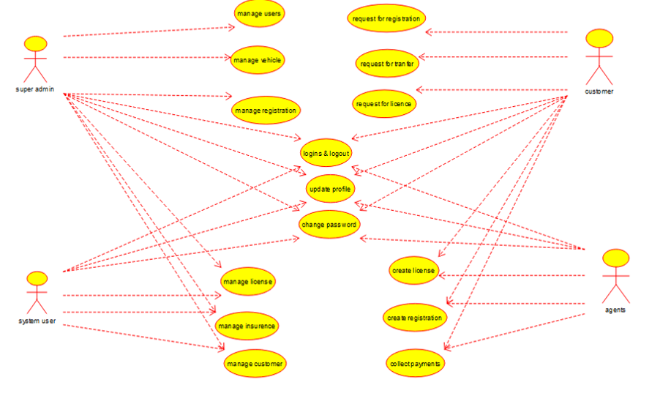

CLASS DIAGRAM:

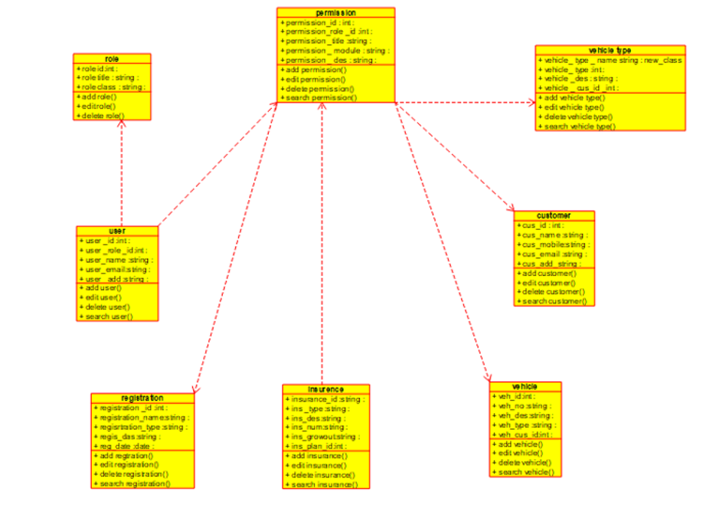

ACTIVITY DIAGRAM: 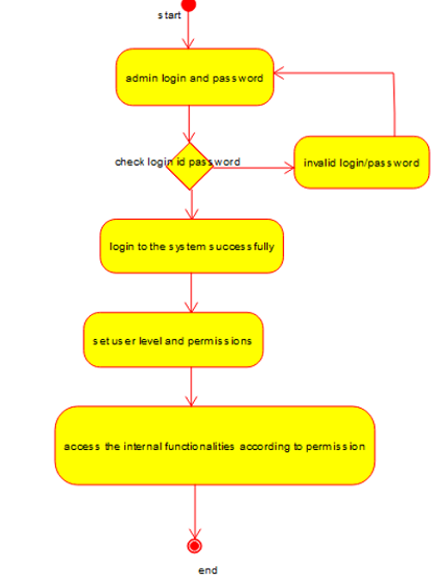

SEQUENCE DIAGRAM: 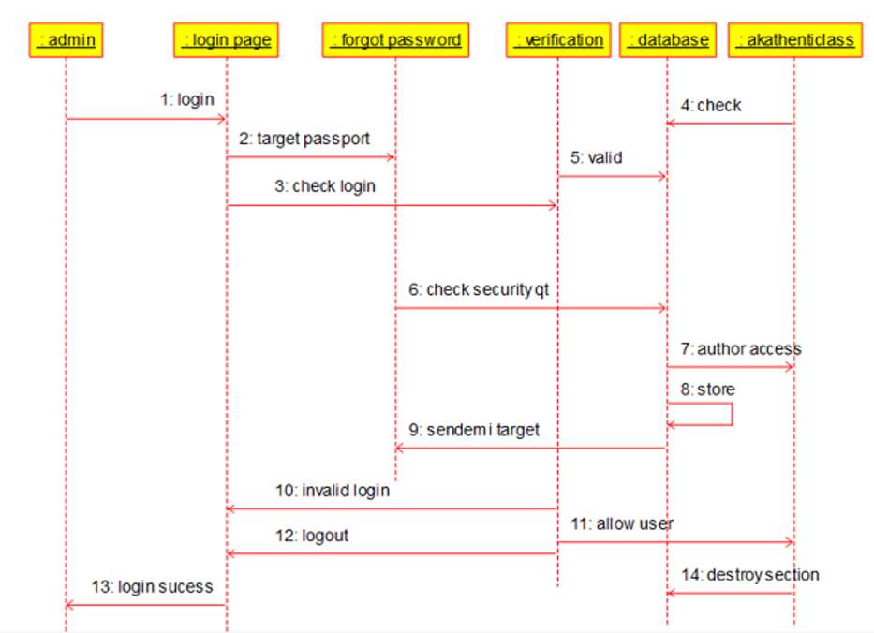

COLLABRATION DIAGRAM: 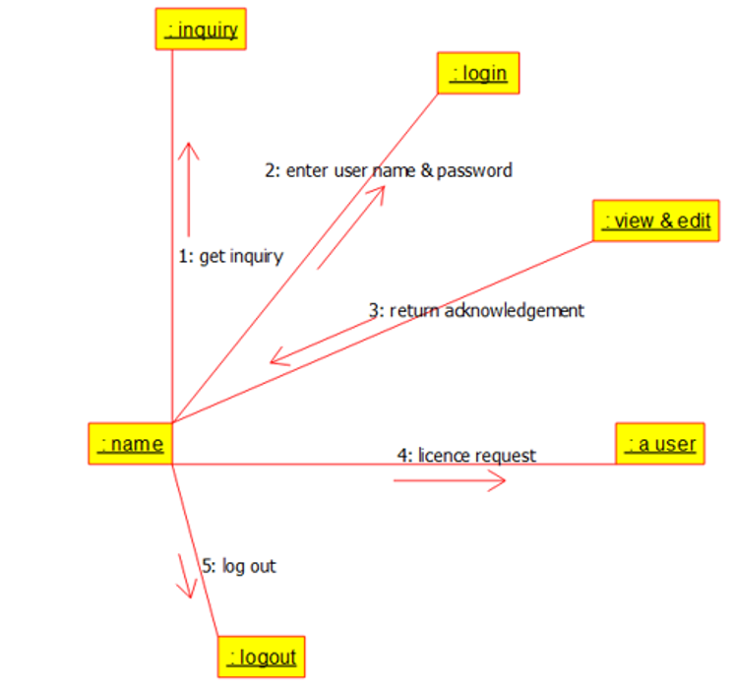

COMPONENT DIAGRAM: 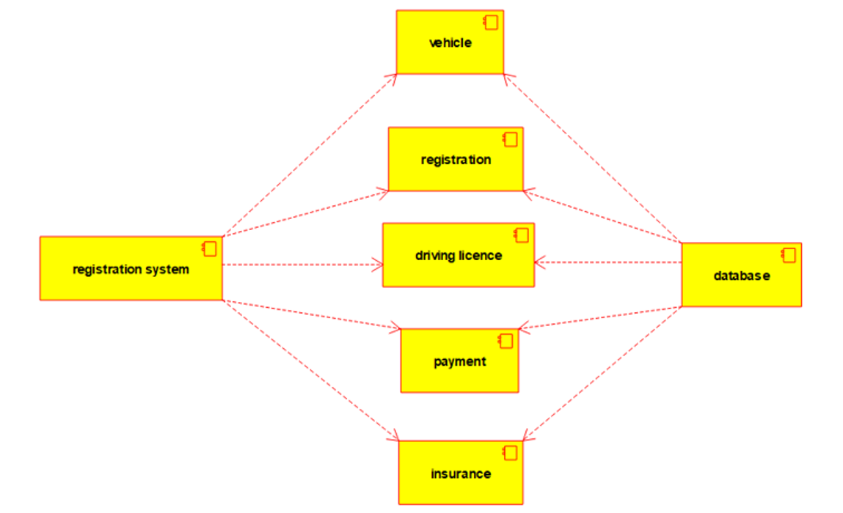

DEPLOYMENT DIAGRAM: 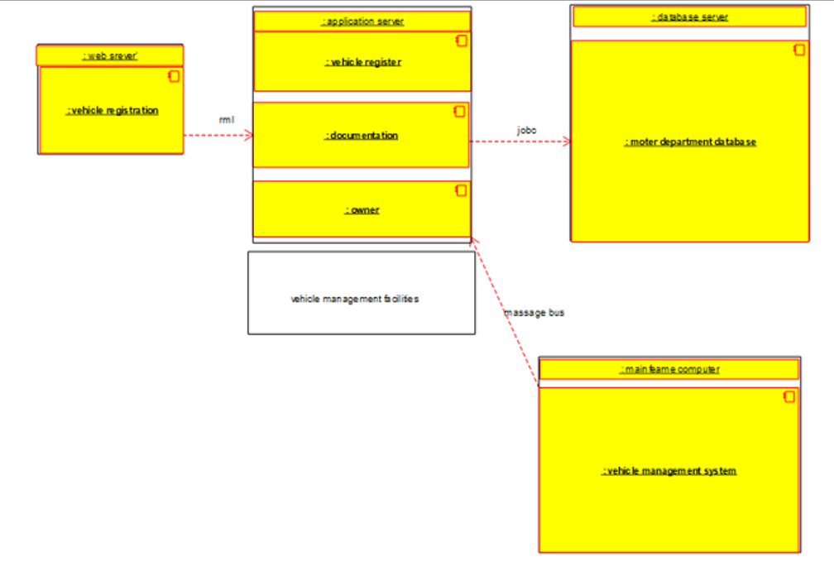

PROGRAM:

/**

* Class customer

*/

public class customer {

//

// Fields

//

public void cus_id_int;

public void cus_name_string;

public void cus_mobile_string;

public void cus_email_string;

public void cus_add_string;

//

// Constructors

//

public customer () { };

//

// Methods

//

//

// Accessor methods

//

/**

* Set the value of cus_id_int

* @param newVar the new value of cus_id_int

*/

public void setCus_id_int (void newVar) {

cus_id_int = newVar;

}

/**

* Get the value of cus_id_int

* @return the value of cus_id_int

*/

public void getCus_id_int () {

return cus_id_int;

}

/**

* Set the value of cus_name_string

* @param newVar the new value of cus_name_string

*/

public void setCus_name_string (void newVar) {

cus_name_string = newVar;

}

/**

* Get the value of cus_name_string

* @return the value of cus_name_string

*/

public void getCus_name_string () {

return cus_name_string;

}

/**

* Set the value of cus_mobile_string

* @param newVar the new value of cus_mobile_string

*/

public void setCus_mobile_string (void newVar) {

cus_mobile_string = newVar;

}

/**

* Get the value of cus_mobile_string

* @return the value of cus_mobile_string

*/

public void getCus_mobile_string () {

return cus_mobile_string;

}

/**

* Set the value of cus_email_string

* @param newVar the new value of cus_email_string

*/

public void setCus_email_string (void newVar) {

cus_email_string = newVar;

}

/**

* Get the value of cus_email_string

* @return the value of cus_email_string

*/

public void getCus_email_string () {

return cus_email_string;

}

/**

* Set the value of cus_add_string

* @param newVar the new value of cus_add_string

*/

public void setCus_add_string (void newVar) {

cus_add_string = newVar;

}

/**

* Get the value of cus_add_string

* @return the value of cus_add_string

*/

public void getCus_add_string () {

return cus_add_string;

}

//

// Other methods

//

/**

*/

public void add_customer()

{

}

/**

*/

public void edit_customer()

{

}

/**

*/

public void delete_customer()

{

}

/**

*/

public void search_customer()

{

}

}

/**

* Class insurence

*/

public class insurence {

//

// Fields

//

public void insurance_id_string;

public void ins__type_string;

public void ins_des_string;

public void ins_num_string;

public void ins_growout_string;

public void ins_plan_id_int;

//

// Constructors

//

public insurence () { };

//

// Methods

//

//

// Accessor methods

//

/**

* Set the value of insurance_id_string

* @param newVar the new value of insurance_id_string

*/

public void setInsurance_id_string (void newVar) {

insurance_id_string = newVar;

}

/**

* Get the value of insurance_id_string

* @return the value of insurance_id_string

*/

public void getInsurance_id_string () {

return insurance_id_string;

}

/**

* Set the value of ins__type_string

* @param newVar the new value of ins__type_string

*/

public void setIns__type_string (void newVar) {

ins__type_string = newVar;

}

/**

* Get the value of ins__type_string

* @return the value of ins__type_string

*/

public void getIns__type_string () {

return ins__type_string;

}

/**

* Set the value of ins_des_string

* @param newVar the new value of ins_des_string

*/

public void setIns_des_string (void newVar) {

ins_des_string = newVar;

}

/**

* Get the value of ins_des_string

* @return the value of ins_des_string

*/

public void getIns_des_string () {

return ins_des_string;

}

/**

* Set the value of ins_num_string

* @param newVar the new value of ins_num_string

*/

public void setIns_num_string (void newVar) {

ins_num_string = newVar;

}

/**

* Get the value of ins_num_string

* @return the value of ins_num_string

*/

public void getIns_num_string () {

return ins_num_string;

}

/**

* Set the value of ins_growout_string

* @param newVar the new value of ins_growout_string

*/

public void setIns_growout_string (void newVar) {

ins_growout_string = newVar;

}

/**

* Get the value of ins_growout_string

* @return the value of ins_growout_string

*/

public void getIns_growout_string () {

return ins_growout_string;

}

/**

* Set the value of ins_plan_id_int

* @param newVar the new value of ins_plan_id_int

*/

public void setIns_plan_id_int (void newVar) {

ins_plan_id_int = newVar;

}

/**

* Get the value of ins_plan_id_int

* @return the value of ins_plan_id_int

*/

public void getIns_plan_id_int () {

return ins_plan_id_int;

}

//

// Other methods

//

/**

*/

public void add_insurance()

{

}

/**

*/

public void edit_insurance()

{

}

/**

*/

public void delete_insurance()

{

}

/**

*/

public void search_insurance()

{

}

}

/**

* Class permission

*/

public class permission {

//

// Fields

//

public void permission_id_int;

public void permission_role__id_int;

public void permission__title_string;

public void permission___module_string;

public void permission___des_string;

//

// Constructors

//

* @param newVar the new value of vehicle__des_string

*/

public void setVehicle__des_string (void newVar) {

vehicle__des_string = newVar;

}

/**

* Get the value of vehicle__des_string

* @return the value of vehicle__des_string

*/

public void getVehicle__des_string () {

return vehicle__des_string;

}

/**

* Set the value of vehicle___cus_id__int

* @param newVar the new value of vehicle___cus_id__int

*/

public void setVehicle___cus_id__int (void newVar) {

vehicle___cus_id__int = newVar;

}

/**

* Get the value of vehicle___cus_id__int

* @return the value of vehicle___cus_id__int

*/

public void getVehicle___cus_id__int () {

return vehicle___cus_id__int;

}

//

// Other methods

//

/**

*/

public void add_vehicle_type()

{

}

/**

*/

public void edit_vehicle_type()

{

}

/**

*/

public void delete_vehicle_type()

{

}

/**

*/

public void search_vehicle_type()

{

}

}